Gauge Display Control Function – Tach & Temp – CGEA 1.3

Functional Description

The Gauge Display Control Function – Tach & Temp allows the driver to configure which gauges will be displayed in the Cluster Display next to the Message Center display. The selections include Tachometer and Engine Coolant Temperature Gauge. While SST (select shift transmission) mode is active, the Engine Coolant Temperature Gauge selection is not available and the display will automatically change to the Tachometer display. When the driver exits SST Mode, the Gauge_Display_State will revert back to the previous Gauge_Display_State. The Entry into and exit from SST Mode also, will control the M/C_Display_Status. If the driver exits SST mode without changing the M/C_Display_Status via the M/C Switches, the M/C_Display_Status will revert back to the previous M/C_Display_Status, otherwise it will stay in the current display.

The Gauge Display Control Function is intended for use in instrument clusters with dual 4.2" LCD or similar display (i.e. Level 2); it is not intended for use on instrument clusters with a B, E or F display.

Interfaces

Interface Context Diagram (I/O Block Diagram)

Figure 1 Gauge Display Control Function Context Diagram
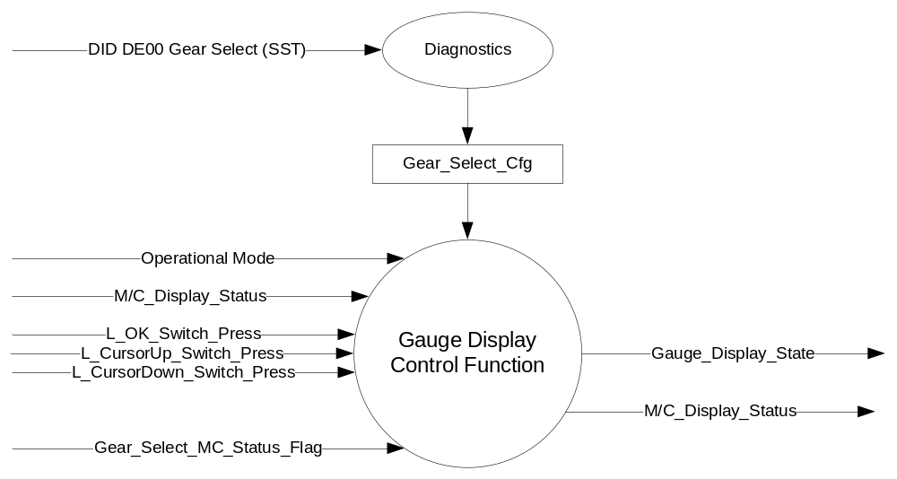

Inputs

      - Operational_Mode
      - M/C_Display_Status
      - L_OK_Switch_Press
      - L_CursorUp_Switch_Press
      - L_CursorDown_Switch_Press
      - Gear_Select_MC_Status_Flag (From Gear Selection Function with primary ePRNDL STSS)
      - Gear_Select_Cfg

Outputs

- Gauge_Display_State
- M/C_Display_Status

Function/Performance

Operational Modes

Mode | Differentiating Vehicle Conditions
Sleep Mode | OFF
Limited Mode | OFF
Normal Mode | Gauge Display ON / OFF
Crank Mode | Gauge Display ON / OFF

The above table references the setting of the flags as per this section. However, the actual Gauge Display operation is defined in the Message Center section of this SPSS.

Voltage Levels

Refer to the Cluster Features Table located in the Operational Modes and Voltage Range Strategies of this SPSS.

Human-Machine Interface

Visual

Indicator Graphics / Display Format
Setting the Gauge Display mode is achieved through the "Settings" menus in the Display Setup section. The following Gauge Display text is only a graphic representation. See Ford Studio released Drawing and VAPS model for exact graphics.

Menu level 3 |  | Menu level 4  `  `  `  `  `  `
T: Display Setup
Gauge Display |  | T: Gauge Display
Gauge Display | ◻ | Coolant Temp | Gauge Display Set to Coolant_Temp
Gauge Display | ☑ | Tachometer | Gauge Display Set to Tachometer

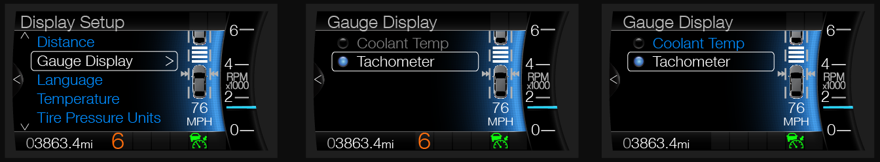
Note: This is only applicable to the Level 2 IPC.

Indicator Color Coordinates

Reference section COLOR & ILLUMINATION REQUIREMENTS (GRAPHICS)

Indicator Characteristics

Refer to Message Center X Display_Y Button Interface Section, where X and Y are appropriate values in this document.

Audio

None

Switch Control Logic

Consumer access to the Gauge Display Control Configuration shall be as specified in the Message Center_SHMI Displays_5 Button Interface (STSS).

System Accuracy

Within a 100msec of receiving a message that results in a change of state the cluster will update the display to the proper status.

Operation: Performance and Functional

Subsystem Algorithm Flowchart / State Diagram

Figure 2 CAN Diagnostic Routine Flowchart

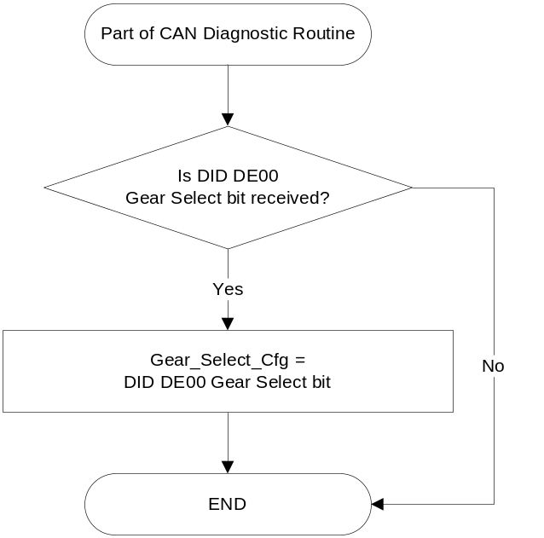

Figure 3 Gauge Display Control Function Flowchart

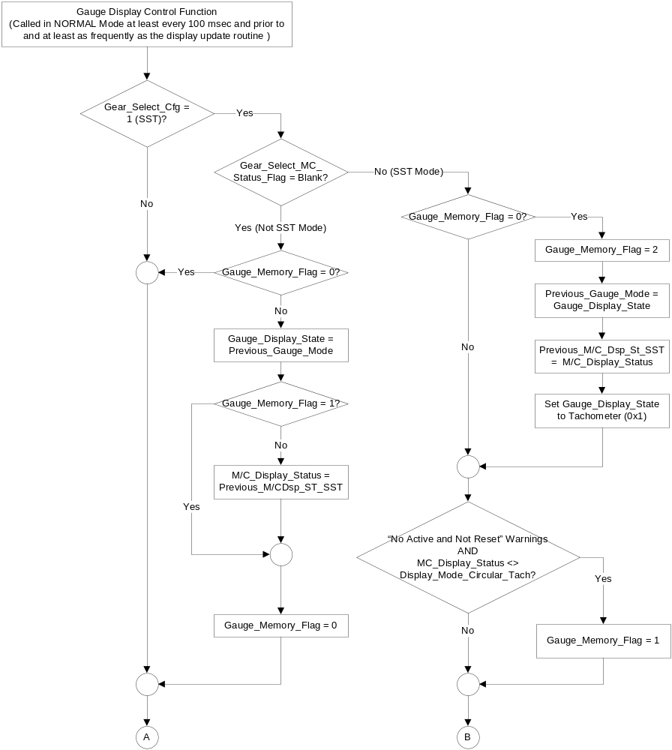

Figure 4 Gauge Display Control Function Flowchart (continued)

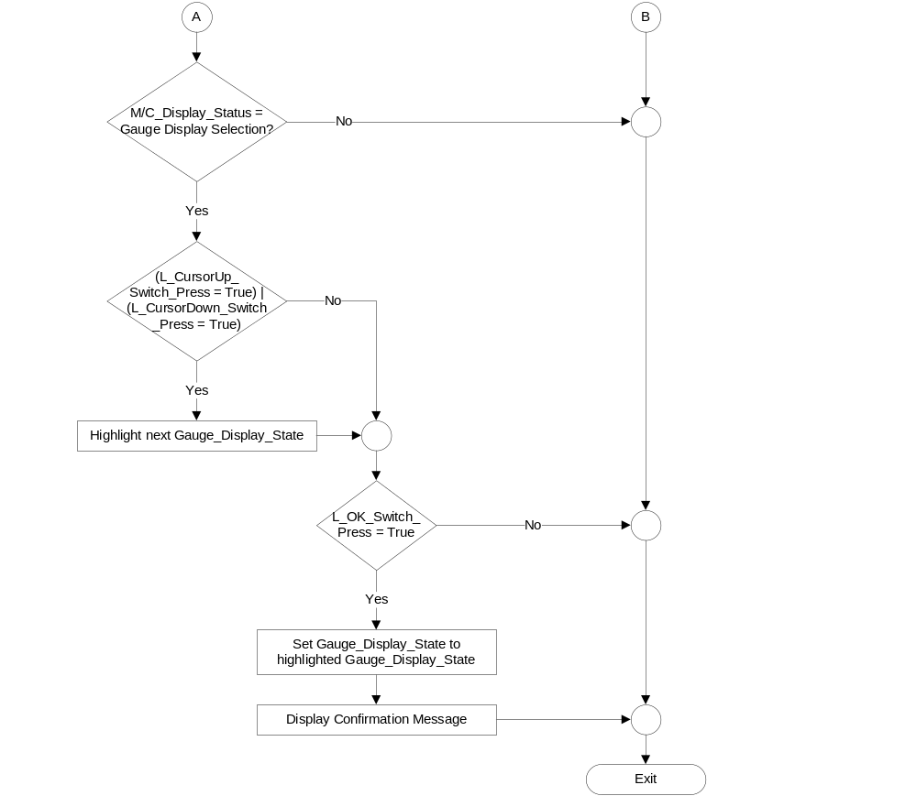

Gear_Select_  MC_Status_Flag | Current Gauge_Display_State | 5-Button Switch  Selection Event | Next Gauge_Display_State
Blank | ☑ Coolant_Temp (0x0)  ◻ Tachometer (0x1) | Up/Down + OK  (Select Tachometer) | ◻ Coolant_Temp (0x0)  ☑ Tachometer (0x1)
Blank | ◻ Coolant_Temp (0x0)  ☑ Tachometer (0x1) | Up/Down + OK  (Select Coolant Temp) | ☑ Coolant_Temp (0x0)  ◻ Tachometer (0x1)
<> Blank | ◻ Coolant_Temp (0x0)  ☑ Tachometer (0x1) | Up/Down + OK  (Select Tachometer) | ◻ Coolant_Temp (0x0)  ☑ Tachometer (0x1)
NOTE: While Gear_Select_MC_Status_Flag <> Blank, the Coolant Temperature Gauge selection is not available and the display will automatically change to the Tachometer display and the Gauge Display Setting for Coolant Temp will be grayed-out in the menu.

Operation Description (supports algorithm flowchart /state diagram)

The Gauge Display Control Function allows the driver to configure which gauges will be displayed while in Gauge Mode. The selections include Coolant Temp and Tachometer.

When in the Gauge Display Setup page, an Up or Down message center button press will highlight the next Menu Setup selection. An OK message center button press while on this page will set the Gauge_Display_State output to the highlighted selection and the screens will be displayed with the selected Gauge_Display_State.

When SST (select shift transmission) mode becomes active, Gauge_Display_State will be set to Tachometer and the display will automatically change to Display Mode – Circular Tachometer. While SST (select shift transmission) mode is active, the Coolant Temp Gauge selection is not available and the "Coolant Temp" setting will be grayed out. When the driver exits SST mode, the Gauge_Display_State will be set to the state it was before SST became active and the display will adjust accordingly. If the driver exits SST mode without changing the Message Center Display, the Message Center Display will be set to the state it was before SST became active and the display will adjust accordingly.

Function Safety Classification (EMC)

B

Memory Storage

Parameter Name | Description | Value at Battery connect | Value at  Module Wake-up
M/C_Display_Status | Input to this routine that is a State Indicator to identify which text is currently being displayed on Message Center display. | See Message Center_SHMI Displays_5 Button Interface STSS | See Message Center_SHMI Displays_5 Button Interface STSS
Operational_Mode | Input to this routine that is a 4 State indicator for cluster operational mode | As per Operational Modes and Voltage Range Strategies Section (STSS) | As per Operational Modes and Voltage Range Strategies Section (STSS)
Gauge_Display_State | Output that controls which gauges will be displayed while in Gauge Mode | Coolant_Temp (0x0) | Do Not Init
Previous_Gauge_Mode | Variable that stores the value of Gauge_Display_State when SST transitions from OFF to ON. | Coolant_Temp (0x0) | Do Not Init
Previous_M/C_Dsp_St_SST | Variable that stores the value of M/C_Display_Status when SST transitions from OFF to ON. | Main Menu | Do Not Init
Gauge_Memory_Flag | Flag that determines if the Gauge_Display_State has been saved in Previous_Gauge_Mode.  0 = Previous States not saved  1 = Restore only Gauge_Display_State  2 = Restore both Gauge_Display_State and M/C_Display_Status | 0 (Previous States not saved) | 0 (Previous States not saved)
L_OK_Switch_Press | Reference Message Center Switch - 5 Button HSCAN Interface STSS | See Message Center Switch - 5 Button HSCAN Interface STSS | See Message Center Switch - 5 Button HSCAN Interface STSS
L_CursorUp_Switch_Press | Reference Message Center Switch - 5 Button HSCAN Interface STSS | See Message Center Switch - 5 Button HSCAN Interface STSS | See Message Center Switch - 5 Button HSCAN Interface STSS
L_CursorDown_Switch_Press | Reference Message Center Switch - 5 Button HSCAN Interface STSS | See Message Center Switch - 5 Button HSCAN Interface STSS | See Message Center Switch - 5 Button HSCAN Interface STSS
Gear_Select_MC_Status_Flag | Used to control the state of the display for the Message Center arbitrator (See Gear Selection Function with primary ePRNDL STSS or Gear Selection Function with primary ePRNDL and Range Select STSS) | Blank | Blank
Gear_Select_Cfg | State Indicator for feature presence controlled via CAN at EOL at VO plant. Defaulted to Non-SST at supplier manufacturing (See Gear Selection Function with primary ePRNDL STSS or Gear Selection Function with primary ePRNDL and Range Select STSS). | Use Stored Value | Use Stored Value

Prove Out

No

Reconfigurable Telltale

No

Message Center Msg

Reference displays in section 1.3.5.1.

Error Handling

Missing Message Strategy

There is no missing message strategy for this STSS.

Diagnostics

Self Test
None

Engineering Test Mode
None

Part II Performance

Supported Diagnostic Trouble Codes (DTCs)
DTC | Description | When Logged

DID DE00
Block  Num | Block Description | Byte(s) | Bits | State: Description | "0" | "1" | Default | Comments/ Information
PACKETED BLOCKS
$00 | Option Content (B&A) | * | * | Gear Select | Non-SST | SST | Non-SST

Reference Specification

Gear Selection Function with primary ePRNDL STSS
Gear Selection Function with primary ePRNDL and Range Select STSS
Revision History

SPSS Module Revision History
Revision Level | Name | Change Description | Date
1.0 | Tcwik1 | Initial Release, based upon Gauge Display Control Function – Tach & Temp – CGEA1.3_v3.1 | 8/27/2013

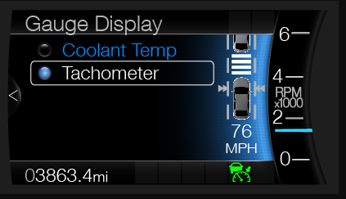
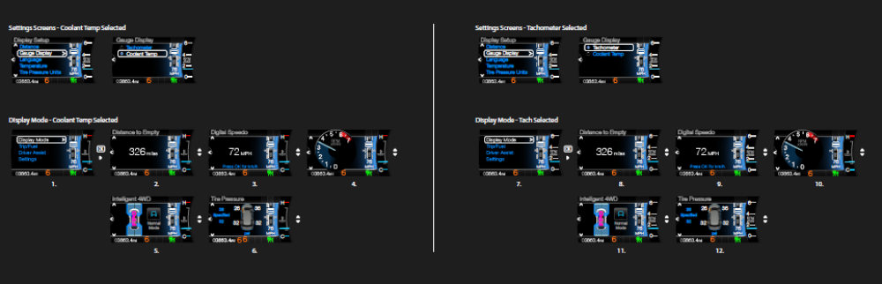
Display Mode
- When the "Gauge Display" setting is set to "Engine Coolant", the walk across Display Mode is screen 1 → 2 → 3 → 4 → 5 → 6.
- When the "Gauge Display" setting is set to "Tachometer" the walk across Display Mode is screen 7 → 8 → 9 → 10 → 11 → 12.
SST
- If SST is turned from OFF to ON while the LHS (M/C_Display_Status) is displaying any cluster screen, then the LHS will transition to display screen 10.
- When SST is ON, the "Gauge_Display_State" is set to the "Tachometer" setting.
- When SST is ON, the setting "Coolant Temp" will be grayed out and NOT selectable in the settings menu.
- When SST is turned from ON to OFF, the "Gauge_Display_State" setting will return to the state it was before SST was turned ON and the display will adjust accordingly.
- When SST is turned from ON to OFF, if the driver did not change the M/C_Display_Status via the M/C Switches while in SST mode, the M/C_Display_Status will revert back to the previous M/C_Display_Status, otherwise it will stay in the current display.

